Spring 2020 CIS2277 C++ III Program 7
Building a Hash Table, Hash Function using a SearchableListMgr and Persons

Program 7 300 points breakdown: 50 pts documentation in *.h as requested here
25 pts log file, formatting, easy to read and completeness
25 pts correct implementation of SearchableLinkedList
200 pts program

Program Requirements:
- Name your project LastnameP7
- 5 pts Write your name, email address and file name at the top of your source code in a comment.
- 5 pts Write a class header that is the first thing that is seen when you run the program. It should include your name, program title, and program objective.
- 5 pts Use good C++ programming style and formatting for your program and use appropriate comments to explain what you are doing.
Turn in requirements:
- 10 pts Upload your development project folder, named LastnameP1 (such as NelsonP1) to Brightspace. Delete the debug and ipch folders and the Browse.VC file before zipping the project to upload.
- Turn in your log file to Brightspace, either inside your project or separately. There is only one assignment.

Hash Table Description: (From Wikipedia) http://en.wikipedia.org/wiki/Hash_table#Hash_function
In computer science, a hash table or hash map is a data structure that uses a hash function to map identifying values, known as keys (e.g., a person's name), to their associated values (e.g., their telephone number). The hash function is used to transform the key into the index (the hash) of an array element (the slot or bucket) where the corresponding value is to be sought.
Ideally, the hash function should map each possible key to a unique slot index, but this ideal is rarely achievable in practice (unless the hash keys are fixed; i.e. new entries are never added to the table after creation). Most hash table designs assume that hash collisions—the situation where different keys happen to have the same hash value—are normal occurrences and must be accommodated in some way.
In a well-dimensioned hash table, the average cost (number of instructions) for each lookup is independent of the number of elements stored in the table. Many hash table designs also allow arbitrary insertions and deletions of key-value pairs, at constant average (indeed, amortized) cost per operation.
In many situations, hash tables turn out to be more efficient than search trees or any other table lookup structure. For this reason, they are widely used in many kinds of computer software, particularly for associative arrays, database indexing, caches, and sets.
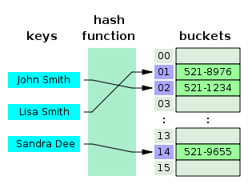
A small phone book as a hash table.

In this article, the authors go on to discuss Chaining and using a linked list to chain the elements into the buckets. In other words, each bucket contains our SearchableListMgr,

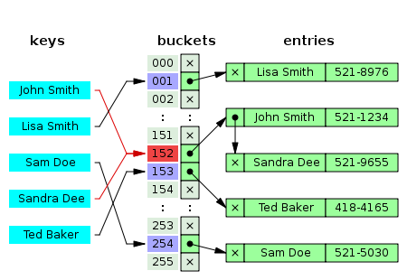

Program Specifications: Each of you will build a Hash Table class that is used to store Person* objects.

Your Hash Table class will have an array of SearchableListMgrs that is sized to 100.

In your HashFunction you will need to use the name of the person and the birthday (3 integer values) to calculate an index value between 0 and 99. This index represents the element in the array of SearchableListMgrs where that Person* will be stored. Your program will obtain a Person * from the PersonGenerator and store it in the HashTable. It will be pushed onto the end of the list at the appropriate SearchableListMgr.

Part of this assignment is to determine and then generate evenly distributed index values, so that the lists are all “about” the same size after you’ve hashed in all the people. Otherwise, you are back to searching an unsorted list.

Program Flow:

In this program, we’ll make use of two PersonGenerator objects so we don’t have to type in any people data.

Your program will be writing a log file that contains all the results of your work. You’ll be using two Person files that I give you. One file will contain the 2000 people for you to store in your HashTable, The second will be a list of people that you’ll be searching for in your HashTable.

1. Have your program write the header information into your log file. Please log the names of the two files I provide for testing.

2. Please name the output file that the program writes: Lastname_P7_Log.txt. You may also add the date and time. (such as Smith_P7_Log_Apr20_17:30.txt)

3. In a loop, using the text file I provide on the due date, obtain 2000 Person objects (Person*) by calling GetNewPerson(). Pass these Person* objects into the HashFunction.

4. Once you have stored your 2000 objects, please call the AnalyzeTable function. You will need to pass in an integer array sized to 100, and a total size for the array (i.e., 100). The HashTable will run through its table array, asking each SearchableListMgr for its count. Fill these values in the array—it will represent the distribution of objects in the table. Ideally each Mgr in your table will have around 20 nodes. Your main will write the array element number, number in each ListMgr and % of 2000 to the output log file. Please have several values on each line so that when I print this file, it will be very page-efficient.

5. You’ll set up a loop that uses a second PersonGenerator to obtain Persons from the “ToFind” file that I give you. For each of the persons in the file, obtain the Person, pull out the name and birthday. Pass these four values into the GetValue function and obtain the associated Person*. Remember, if Person* is stored in the HashTable, it will return a valid pointer and you’ll be able to obtain the person information (use GetFullDesc() ). If the person is not present the GetValue returns a NULL Person *.

In summary: your log file should be formatted neatly and efficiently. It should show your header info and my two testing files. It should show the distribution of how the 2000 Persons were hashed into the table of 100 SearchableListMgrs. It should then give information for the “ToFind” people. It needs to report the name and age for each person. Then show whether that individual is stored in the HashTable and all info.

Documentation In your Hashtable.h please address the following items :

1) describe clearly what your scheme is for your hash function.
2) Give at least 2 specific examples of how your hash calculations will generate a number between and including 0-99.
3) Address how you are insuring that you will not calculate a value outside this range.

Code: Here is the Hashtable.h that you should use:
//For next time. Add a private function just for the hashing algorithm. It can be accessed from Hash Function and from the GetValue Function.
The GetValue Function can return the index of the array where the Person* is located.

class HashTable
{
private:
SearchableListMgr *table; //pointer for an array of ListMgrs (Linked Lists)

//in Constructor do table = new SearchableListMgr[100];

public:
HashTable(); //constructor

void HashFunction(Person *p); //hash function for storing a Person
//key into an index

//finds and returns the Person pointer that matches exactly
void GetValue(string name, int mm, int dd, int yy, Person **value);

//analyze how well the table is balanced
void AnalyzeTable(int distribution[], int total);

//destructor
~HashTable();
};

